The 1CEVG Coin

The sample coins have arrived. There are some differences from the original coin. You might remember the original vendor went out of business. Please examine the pictures and give me your opinion. The pictures might not be of sufficient clarity to discern the differences.

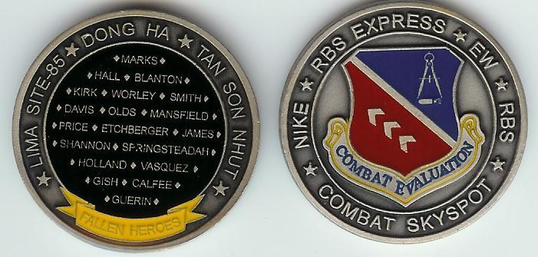

Figure 1: THE ORIGINAL COIN

The original coin (Fig 1) had a clear coat finish on the back, which feels smooth to touch. The front side has the clear coat finish on the emblem only.

Figure 2: TWO VERSIONS OF NEW COIN FRONT SIDE

The front side of the new coin on the left (Fig 2) is similar to the original with the clear coat finish on the emblem. The front side of the new coin on the right has the clear coat finish on the entire front side. You might notice a slight reflection of the clear coat below the word COMBAT SKYSPOT.

The back side of the new coin (Fig 3) is identical to the original. However, the yellow color is not as dark, and the words FALLEN HEROES on the banner is slightly more readable. The size of the coin might be very slightly larger in diameter.

Figure 3: NEW COIN BACK SIDE

Let me know your opinions of the new coin. I must make a decision on which version of the front side to produce. I’ll consider your comments until midnight January 20th. On January 21st I’ll tell the new vendor to produce the first 100 coins of the new version. You can send your comments to me at Indiapapa2003@yahoo.com, or post them in the MESSAGES section for the entire group to read. I hope to ship new coins around March 1st.

Larry Williams

