“The Second Battle of Hastings”

George G. Neville, Jr.
4150 Leo Hansen Road
Florence, Montana 59833
406/273-9048
Neville@blackfoot.net

Mr. Joe Carpenter
2420 HWY 17-A So.
Summerville, SC 29483

Mr. Joe Schumann
P.O. Box 1809
Hawthorne, NV 89415-1809

21 June 2001

Dear “Joe’s”

Enclosed are some of the history documents I promised you. They are only brief summaries but as I have found in my past research-its about a “best you get” from Military Archives. I do believe they will be quite helpful.

One of my beliefs is that – all documents pertaining to the Viet-Nam War should be shared and not horded as some researchers do. Yes, I spent a great deal of time and expense to obtain these but that is no excuse for not sharing. I strongly believe in my principle. Anything I send to you, with the exception of my written work product please pass them on or post on a website. These pages would find a good home on the yahoo site in pdf. Format or something similar.

Yes id do have some documents that I will not release until after my book project is finished. That reason is to protect the information contained. Some of the documentation is very sensitive and if the agencies get wind of some of the things I have I believe they will try to discredit them and me. I have had enough problems blowing holes in some very big walls thrown up against me. My work will do much to enlighten our history with fact and not deceit and distortions of the truth.

Again I must emphasize how pleased I am to have made contact with all from Combat Skyspot.

I will send the microfilm histories under separate cover to Joe Schumann when I get a chance.

I will have questions I will pose to both of you after you have had the opportunity to review these papers.

Sincerely

George G. Neville, Jr.

George G. Neville, Jr.
P.O. Box 73
St. Ignatius, Montana 59865
406/745-3310

15 March 1999

HQ AFPC/DPWCS
550 C Street W.
Suite 14
Randolph AFB, TX 78150-4716

Dear Sir,

In connection with my research on a U. S. Marine Corps Operation, that took place in June and July 1966, during the Vietnam War I am requesting assistance in obtaining some additional information.

I am providing a listing of six Air Force personnel who were killed during this engagement. Please see attached document.

Please check the casualty folders of each man and provide the following information.

- Military Occupational Specialty by code and description.

- Military installation these men were TDY from. It is my understanding that each were on temporary duty and were all from different Air Force Bases not in Vietnam. Further they were TDY to APO-96227.

- The name of the unit they were assigned to at the time of casualty.

For your information these men were riding in a vehicle that was stopped by the North Vietnamese Army and were executed by gunshot wounds to the head.

This incident occurred on 05 June 1966 near Dong Ha Vietnam.

Any help you may be able to provide will be greatly appreciated.

Sincerely,

George G. Neville, Jr.
DEPARTMENT OF THE AIR FORCE
HEADQUARTERS AIR FORCE PERSONNEL CENTER
RANDOLPH AIR FORCE BASE TEXAS

HQ AFPC/DPWCS
550 C Street West, Suite 14
Randolph AFB, TX 78150-4716

Mr. George G. Neville, Jr.
P.O. Box 73
St. Ignatius, MT 59865

Dear Mr. Neville

This is in response to your letter dated 15 March 1999, for information pertaining to six Air Force personnel killed on 5 June 1966 near Dong Ha, Vietnam.

We requested their personnel records from the National Personnel Records Center in St, Louis, MO, and obtained the following information:

All members were temporarily assigned to Operating Location 21, 1st Combat Evaluation Group, Dong Ha, Vietnam. On 5 June 1966, they were on a routine survey 2 miles south of Dong Ha, Vietnam, establishing a visual reference point for determining the location of the equipment.

Technical Sergeant Bruce E. Mansfield’s Air Force Specialty Code was 30373, Non Commissioning Officer in Charge of Automatic Tracking Radar and Associated Equipment. He was responsible for the operational capability and accuracy of the AN/MSQ-2 automatic tracking radar and its associated equipment. He was assigned to Detachment 10, 10th Radar Bomb Scoring Squadron, Hastings Air Force Station, Nebraska.

Technical Sergeant Antone P. Marks’ Air Force Specialty Code was 22271, Data Computer Technician. He was responsible for surveying of radar bomb scoring site locations, computing primary traverse, using methods that ensured at least 2nd order and accuracy. He established positions of latitude and longitude of the radar bomb scoring sites, calibration targets, and simulated aiming points. Supervised the preparation of target data sheets, target folders and associated correspondence pertaining to survey data. He was assigned to 1st Combat Evaluation Group, Barksdale AFB, LA.

Staff Sergeant John P. Guerin’s Air Force Specialty Code was 22251, Data Computer Specialist. He was responsible for radar bomb scoring/Nike target information used for scoring SAC bomber crew simulated releases. Prepares worksheets for use by Army Map Service in computing Inverse Position computations. Obtained geodetic control data and appropriate map coverage for surveys at proposed radar bomb scoring sites. Reviewed pre-reconnaissance plans to be used by field survey teams. He was assigned to 1st Combat Evaluation Group, Barksdale AFB, LA.

Staff Sergeant Ephraim Vasquez’s Air Force Specialty Code was 22251, Data Computer Specialist. He was responsible for computing target data for radar bombsites. Operates electrotapes and theodolites in assisting survey teams in the geodetic surveying of radar bombsites remote and express locations. Computes survey data from field notes. Used maps and charts for plotting and obtaining site and target data. He was assigned to 1st Combat Evaluation Group, Barksdale AFB, LA.

Airman First Class Rufus L. James’ Air Force Specialty Code was 22251, Data Computer Specialist. He was responsible for making measurements consistent with 3rd order accuracy or higher, with theodolite and electrotape. He performed geodetic and grid computations to convert field data to geodetic positions for RBS sites and simulated aiming points. He was assigned to 1st Combat Evaluation Group, Barksdale AFB, LA.

Airman First Class Jerry D. Olds’ Air Force Specialty Code was 30353, Radar Operator/Mechanic. He was responsible for operating automatic tracking radar equipment, identifying targets on radar video scopes and controlling tracking of aircraft. He performed calibration, preventive and corrective maintenance of radar equipment under the supervision of the radar bomb scoring operations crew chief. He was assigned to Detachment 10, 10th Radar Bomb Scoring Squadron, Hastings Air Force Station, Nebraska.

We have attached copies of the DD Form 1300, Report of Casualty, on all of the above members. Personal information of other individuals (social security number, address, etc.) is deleted from all documents to protect their privacy. This information doesn’t pertain to your request per Air Force Instruction 37-132, Chapter 4, paragraph 4.4.4.

Sincerely

GORIA J MICK, CMSgt, USAF
Chief, Casualty Services Branch

Attachment:
Six DD Form 1033
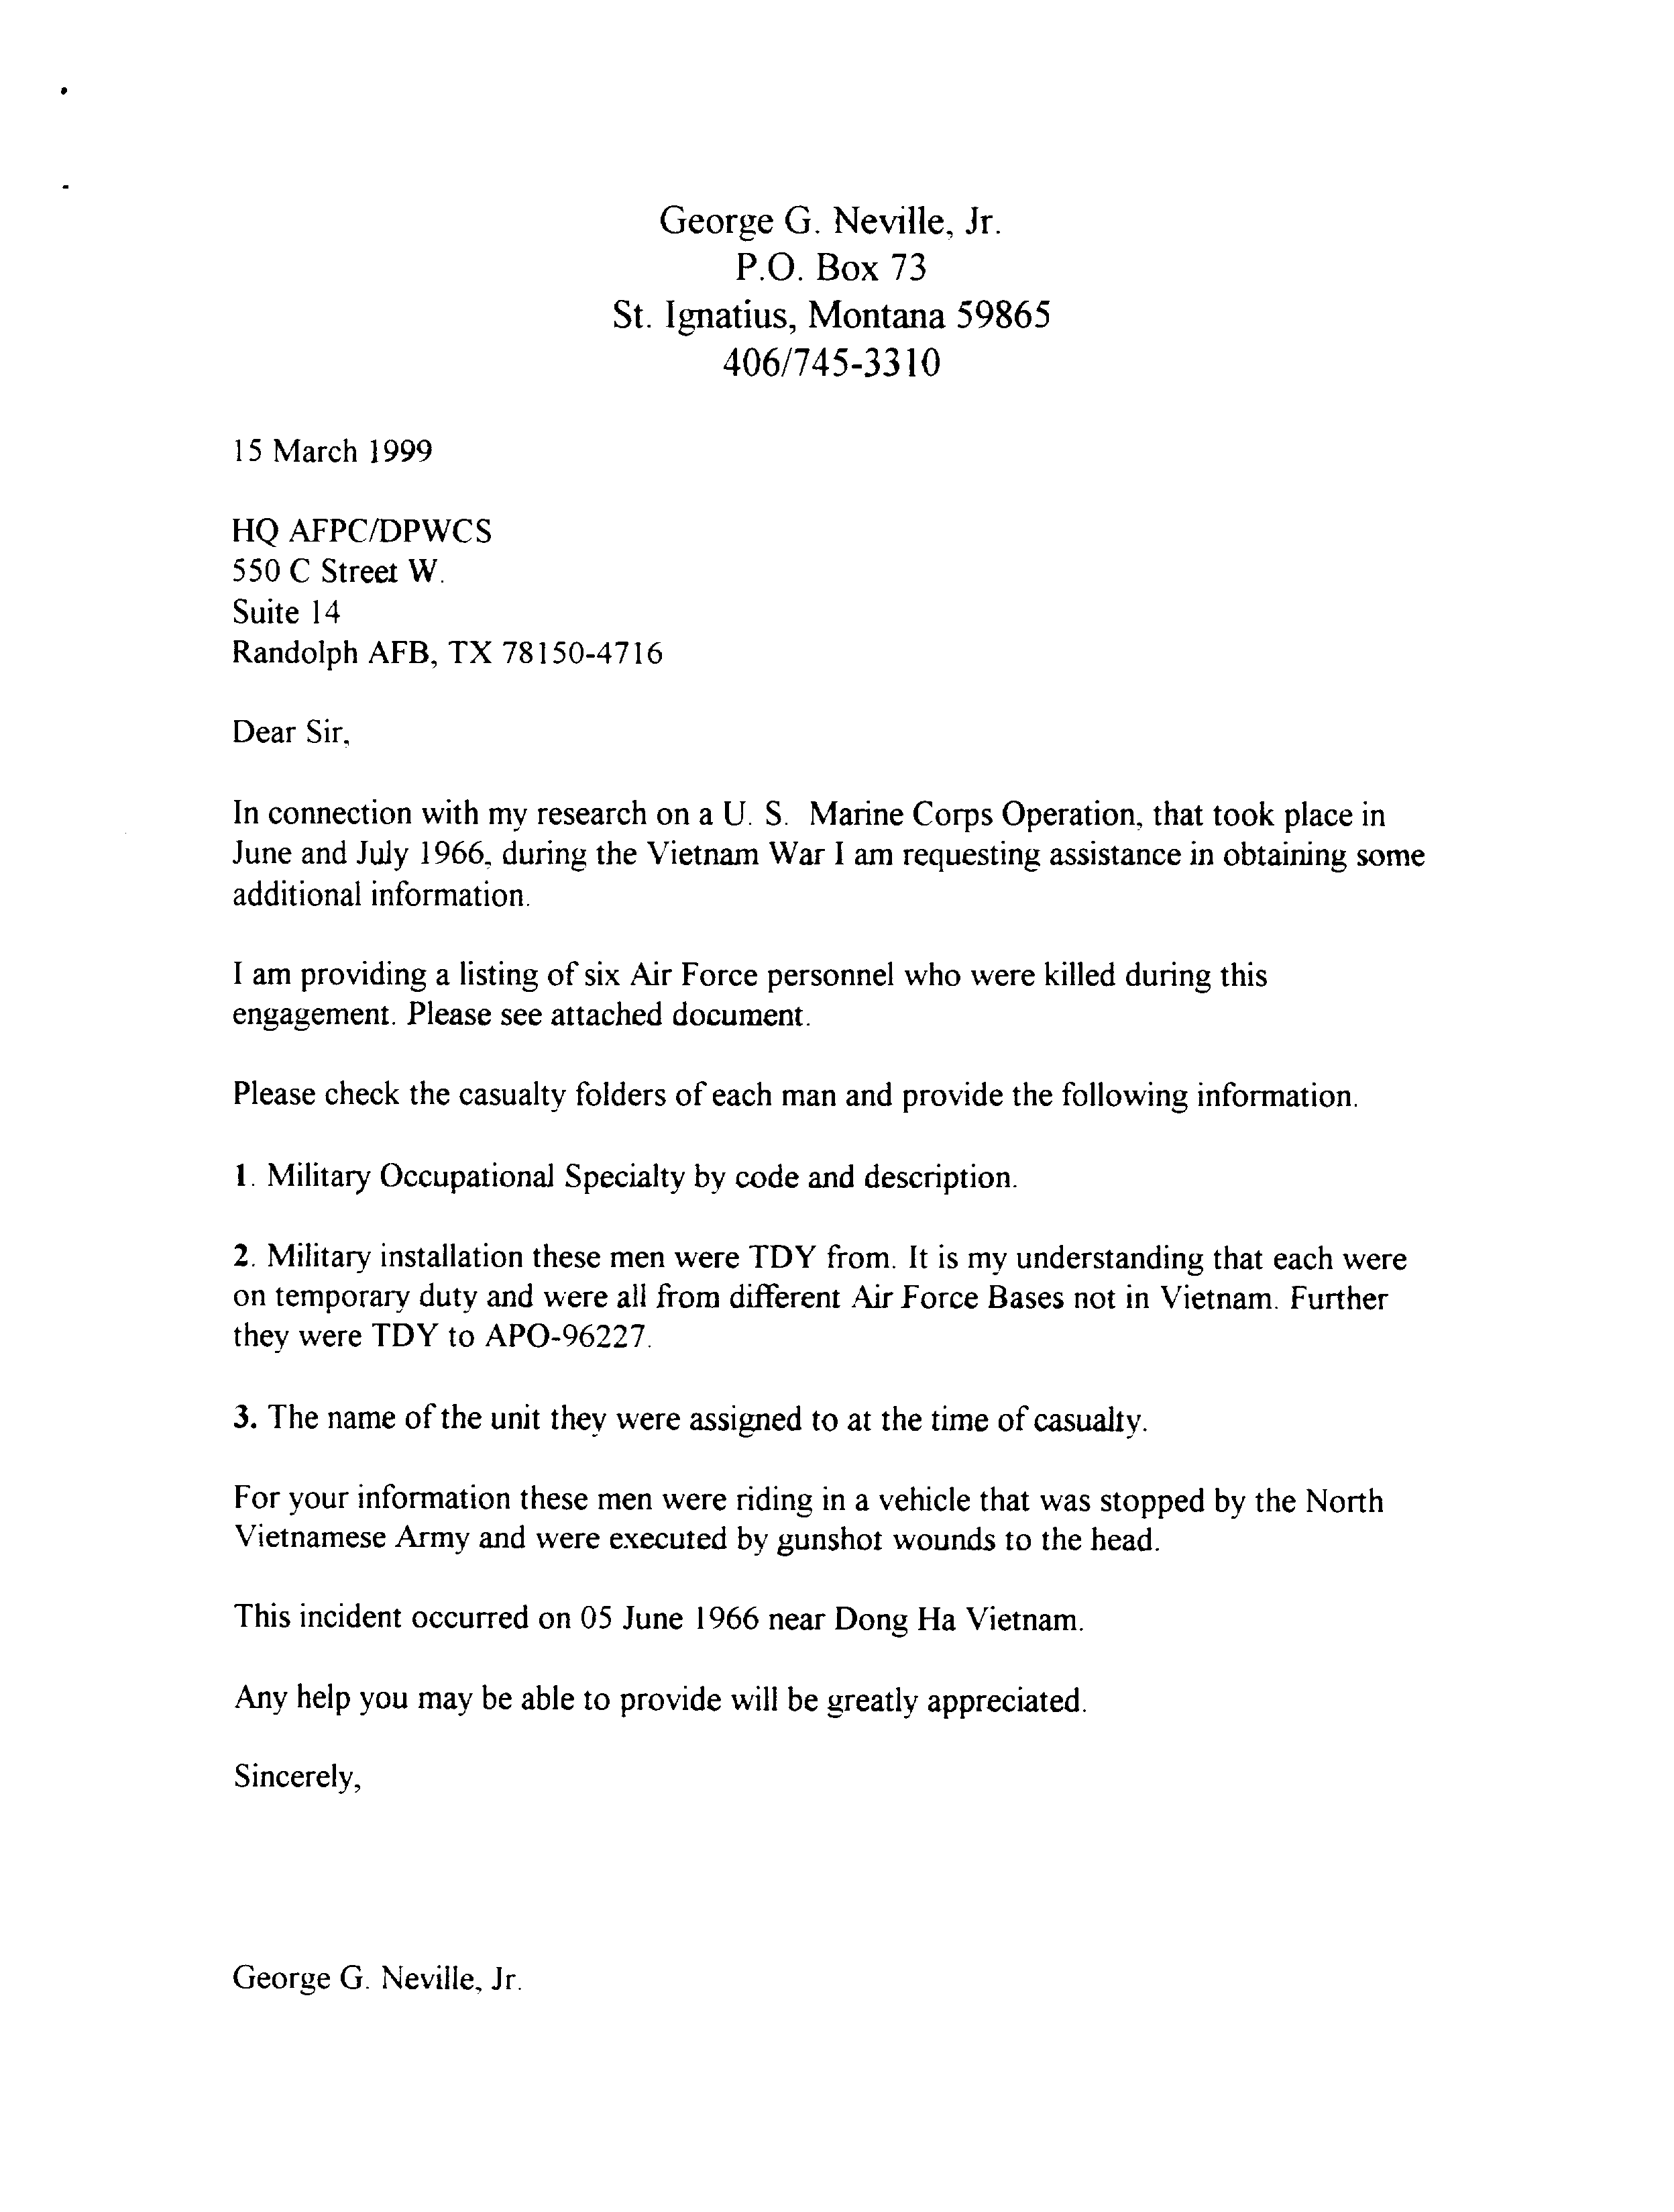

DEPARTMENT OF THE AIR FORCE
HEADQUARTERS AIR PORCE PERSONNEL CENTER
RANDOLPH AIR FORCE SASE TEXAS

HQ AFPC/DPWCS
550 C Street West, Suite 14
Randolph AFB TX 78150-4716

Mr. George G. Neville, Jr.

P.O. Box 73
St. Ignatius, MT 59865

Dear Mr. Neville

This is in response to your letter dated 15 March 1999, for information pertaining to six Air Force personnel killed on 5 June 1966 near Dong Ha. Vietnam.

We requested their personnel records from the National Personnel Records Center in St. Louis, MO, and obtained the following information:

All members were temporarily assigned to Operating Location 21, 1st Combat Evaluation Group, Dong Ha, Vietnam. On 5 June 1966, they were on a routine survey 2 miles south of Dong Ha, Vietnam, establishing a visual reference point for determining the location of the equipment.

Technical Sergeant Bruce E. Mansfield's Air Force Specialty Code was 30373, Non Commissioning Officer in Charge of Automatic Tracking Radar and Associated Equipment. He was responsible for the operational capability and accuracy of the AN/MSQ-2 automatic tracking radar and its associated equipment. He was assigned to Detachment 10, l0th Radar Bomb Scoring Squadron, Hastings Air Force Station, Nebraska.

Technical Sergeant Antone P. Marks' Air Force Specialty Code was 22271, Data Computer Technician. He was responsible for surveying of radar bomb scoring site locations, computing primary traverse, using methods that ensured at least 2nd order accuracy. He established positions of latitude and longitude of the radar bomb scoring sites, calibration targets, and simulated aiming points. Supervised the preparation of target data sheets, target folders and associated correspondence pertaining to survey data. He was assigned to 1st Combat Evaluation Group, Barksdale AFB, LA.

Staff Sergeant John P. Guerin' Air Force Specialty Code was 22251, Data Computer Specialist. He was responsible for radar bomb scoring/Nike target information used for scoring SAC bomber crew simulated releases. Prepares worksheets for use by Army Map Service in computing Inverse Position computations. Obtained geodetic control data and appropriate map coverage for surveys at proposed radar bomb scoring sites. Reviewed pre-reconnaissance plans to be used by field survey teams. He was assigned to 1st Combat Evaluation Group, Barksdale AFB, LA.
Staff Sergeant Ephraim Vasquez's Air Force Specialty Code was 22251, Data Computer Specialist. He was responsible for computing target data for radar bombsites. Operates electrotapes and theodolites in assisting survey teams in the geodetic surveying of radar bombsites remote and express locations. Computes survey data from field notes. Used maps and charts for plotting and obtaining site and target data. He was assigned to 1st Combat Evaluation Group, Barksdale AFB, LA.

Airman First Class Rufus L. James' Air Force Specialty Code was 22251, Data Computer Specialist. He was responsible for making measurements consistent with 3rd order accuracy or higher, with theodolite and electrotape. He performed geodetic and grid computations to convert field data to geodetic positions for RBS sites and simulated aiming points. He was assigned to 1st Combat Evaluation Group, Barksdale AFB, LA.

Airman First Class Jerry D. Olds' Air Force Specialty Code was 30353, Radar Operator/Mechanic. He was responsible for operating automatic tracking radar equipment, identifying targets on radar video scopes. and controlling tracking of aircraft. He performed calibration, preventive and corrective maintenance of radar equipment under the supervision of the radar bomb scoring operations crew chief. He was assigned to Detachment 10, 10th Radar Bomb Scoring Squadron. Hastings Air Force Station, Nebraska.

We have attached copies of the DD Form 1300. Report of Casualty, on all of the above members. Personal information on other individuals (social security number, address, etc.) is deleted from all documents to protect their privacy. This information doesn't pertain to your request per Air Force Instruction 37-132, Chapter 4. paragraph 4.4.4.

Sincerely

GLORIA J. MICK CMSgt, USAF
Chief, Casualty Services Branch

Attachment:
Six DD Form 1300



